Antibody titration for surface staining of fresh murine splenocytes

( 96-well plates)

Abstract
Antibody titration in flow cytometry is a calibration procedure used to determine the lowest antibody concentration that still provides robust separation of positive and negative populations without unnecessary reagent excess. Because the apparent optimal concentration depends on the biological sample, clone, fluorochrome, buffer composition, incubation time, temperature, staining volume, and acquisition settings, titration should be performed under conditions that closely match the final assay. This protocol describes a plate-based method for titrating fluorochrome-conjugated antibodies for surface staining of fresh murine splenocytes in 96-well polypropylene V-bottom plates, using a Beckman Coulter CytoFLEX with plate loader. The method can typically be completed in ~4–5 h from fresh spleen to acquisition. The protocol is intended for titration of antibodies used in live-cell surface phenotyping and is not validated for fixation+permeabilization+intracellular staining workflows.

Introduction
Antibody titration in flow cytometry is not a routine staining step but a calibration procedure designed to identify the lowest antibody concentration that still provides useful biological resolution over background. This point is usually near the plateau of the titration curve, where further increases in antibody concentration produce little or no meaningful gain in separation but may increase background, spread, or reagent cost. Because antibody performance depends strongly on the staining context, titration must be performed under conditions that reproduce the final assay as closely as possible, including sample type, fluorochrome, staining buffer, blocking conditions, cell concentration, incubation time, temperature, and acquisition settings [1–3].

Fresh murine splenocytes are a useful titration substrate because they provide abundant immune cells with a broad range of surface-marker densities. However, they also impose practical constraints. They sediment rapidly in plates, can reaggregate before acquisition, and may behave differently from purified or cultured populations if the collection and staining matrices are not controlled. Plate-based titration in V-bottom plates is therefore attractive because it allows multiple serial dilutions to be tested simultaneously on the same freshly prepared cell suspension while maintaining a consistent handling matrix across titration points [5–7].

In this protocol, the antibody incubation is deliberately extended to 60 min at 4 °C. At low temperature, antibody binding proceeds slowly, and longer incubation allows the reaction to approach equilibrium closely. Under these conditions, lower antibody concentrations can still provide adequate staining, improving reagent economy and the practical signal-to-noise ratio [4]. This choice is an optimization strategy and should not be interpreted as a universal rule for all staining workflows.

Comparison with other methods
Compared with tube-based workflows, plate-based formats reduce between-sample variation, and the V-bottom design supports efficient washing and parallel processing. The main limitation is the rapid sedimentation of splenocytes in microplates, which can increase variability and promote reaggregation if acquisition is delayed.

Compared with faster 20–30 min cold surface-staining workflows, the 60 min incubation can improve detection of the lowest practically usable antibody concentration, which may be advantageous in reagent-sparing assays or for populations with low antigen density.

Applications and limitations of the method

This protocol is restricted to:
- titration of fluorochrome-conjugated antibodies for surface staining of fresh murine splenocytes
- 96-well polypropylene V-bottom plates
- 2-fold serial titration across wells A–G, with row H reserved for controls and instrument cleaning
- live-cell acquisition on a Beckman Coulter CytoFLEX with plate loader

This protocol is not validated for:
- fixation or permeabilization with intracellular staining
- phospho-flow or transcription-factor staining
- cryopreserved splenocytes and spleen preparations that require RBC lysis

Because RBC lysis is intentionally omitted, spleens with unusually high erythrocyte burden may yield lower leukocyte purity and more variable acquisition density. Such samples fall outside the optimized scope of this protocol.

Overview of the procedure
Fresh mouse spleens are dissociated mechanically in ice-cold leukocyte collection medium (LCM), filtered through 38 µm nylon mesh, and transferred into cold FACS buffer. Splenocytes are adjusted to 5 × 10^6 cells/mL and plated in a 96-well polypropylene V-bottom plate. For each antibody, a 2-fold serial dilution is prepared across wells A–G. Row H is reserved for controls and instrument cleaning: H1–H3, unstained control; H4–H6, viability-dye control; H7–H12, cytometer cleaning wells. Cells are Fc-blocked, stained for 60 min at 4 °C, washed twice by plate centrifugation, resuspended in FACS buffer, and stained terminally with DAPI or PI before acquisition. DAPI and PI are both membrane-impermeant DNA dyes. In unfixed samples, they are used to identify dead or membrane-compromised cells. If the final panel uses polymer fluorochromes, include True-Stain™ Multi-Fluor Buffer in the titration matrix.

Before you begin

Ethics and regulatory approvals:
All procedures involving mice must be performed in accordance with local institutional and national animal-use regulations. This protocol assumes that the required local approvals are already in place.

Planning step:
- Prepare the plate map so that each antibody occupies one vertical column
- Check in advance whether the tested fluorochrome is detected in the 405/450 channel; if so, use PI rather than DAPI as the terminal viability dye
- Ensure that fresh mouse spleens are available on the day of the experiment
- Book CytoFLEX 20 in advance through the local platform reservation system https://plateforme-cytometrie.med.usherbrooke.ca/

Bench setup:
- Prepare all buffers in advance and keep them at 4 °C or on ice
- Pre-cool the plate centrifuge and organize the cold workspace before starting spleen dissociation

Experimental design
- Each antibody is titrated in one vertical column of a 96-well plate:
- A–G: seven 2-fold serial concentrations; H1–H3: unstained control; H4–H6: viability-dye control; H7–H12: cytometer cleaning wells
- The dilution series is prepared at 2× concentration before cell addition, so that after addition of splenocytes and buffer the wells reach the intended 1× final staining concentrations.
- The top antibody concentration should be selected from the manufacturer’s recommended working range
- The recommended cell input is 5 × 10^6 cells/mL, corresponding to 2.5 × 10^5 cells per well in 50 µl
- Controls include three unstained wells (H1–H3) and three viability-dye control wells (H4–H6), using DAPI by default or PI when the tested fluorochrome is detected in the 405/450 channel. Wells H7–H12 are reserved for cytometer cleaning.

Materials
Biological materials:
- Fresh mouse spleens or a murine splenocyte single-cell suspension prepared in ice-cold leukocyte collection medium (LCM) and filtered before titration

Reagents:
- RPMI-1640 medium
- Fetal bovine serum (FBS)
- PBS, 10×, without Ca^2+/Mg^2+, sterile (WISENT, cat. no. 311-012CL)
- EDTA, 0.5 M, pH 8.0, sterile (WISENT, cat. no. 809-163CL)
- Fluorochrome-conjugated antibody to be titrated
- Fc-block : TruStain FcX™ PLUS (anti-mouse CD16/32; BioLegend, cat. no. 156604)
- BV-buffer: True-Stain™ Multi-Fluor Buffer (BioLegend, cat. no. 426105)
- DAPI, 2 mg/mL stock in 50% glycerol, stored at −20 °C (Sigma-Aldrich, cat. no. D9542)
- Propidium iodide (PI), 5 mg/mL (1000× stock) in 50% glycerol, stored at −20 °C (Sigma P4170)
- Deionized water (DI-water) 0.45 um filtered by the machine
Plasticware and consumables:
- 96-well polypropylene V-bottom microtiter plate (Sigma- cat. no AXYP96450VC )
- Adhesive plate-sealing film (VWR, cat. no. 60941-120)
- Standard plastic plate cover compatible !!! with the selected 96-well plate
- Homemade dual-tip filters fitted with 38 µm nylon mesh (Component Supply, U-CMN-38)
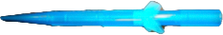
- Pipette tips compatible with 2 µL and 200 µL single-channel pipettes
Equipment:
- Calibrated single-channel pipette, variable-volume, 0.1–2 µL
- Calibrated single-channel pipette, variable-volume, 20–200 µL
- Refrigerated plate centrifuge compatible with 96-well plates
- Ice bucket or cold workspace maintained at 4 °C
- Gentle rotating wheel suitable for cold incubation
- Beckman Coulter CytoFLEX with plate loader

Reagent setup
Leukocyte collection medium (LCM)
- Prepare RPMI-1640 medium supplemented with 10% FBS and keep it ice-cold throughout preparation and use. Use LCM during spleen dissociation and the earliest handling steps. Perform the titration in FACS buffer, not in LCM. An alternative formulation based on 10% heat-inactivated horse serum may be used only if it is part of the validated downstream workflow.)

Solutions:
- Prepare 500 mL of FACS buffer under sterile conditions:
Component | Volume for 500 mL | Final composition
DI-water (approx.) | 300 mL | —
PBS 10× | 50 mL | 1× PBS
FBS | 10 mL | 2% FBS
0.5 M EDTA | 2 mL | 2 mM EDTA
DI-water | up to 500 mL | Adjust final volume

- Prepare DAPI stock at 2 mg/mL (1000× stock) in 50% glycerol and store it at −20 °C
- Prepare PI stock at 5 mg/mL (1000× stock) in 50% glycerol and store it at −20 °C.
- Fc block: prepare TruStain FcX™ PLUS (anti-mouse CD16/32) according to the manufacturer’s instructions
- Prepare the polymer-dye interaction buffer True-Stain™ according to the manufacturer’s instructions if BV fluorochromes are used

Equipment setup
For startup, maintenance, and platform-specific operating details, follow the local CytoFLEX 20 platform instructions used in your facility.

For this protocol, the validated acquisition conditions are as follows:
- Plate-loader mode
- Plate type correctly assigned to V-bottom geometry
- Sample Flow = Slow

Procedure
Preparation of splenocytes from fresh mouse spleen ● Timing 25–35 min
- Place two frosted-end microscope slides in a Petri dish and wet the frosted surfaces with ice-cold LCM.
- Place the freshly isolated mouse spleen on the frosted surface of one slide, then nick the capsule gently with the edge of the second slide.
- Gently crush the spleen between the two frosted slides. Rotate one slide slightly against the other with light pressure until the tissue disperses and splenocytes are released, then rinse both slides with cold LCM to recover the remaining cells.
CRITICAL STEP
Perform the dissociation gently but thoroughly. Excessive mechanical force increases debris and cell damage; incomplete dissociation reduces yield and may bias the recovered cell mixture.
- Collect the splenocyte suspension in cold LCM and keep it on ice.
- Place a 38 µm nylon mesh ditips filter in a 10-mL centrifuge tube
- Centrifuge the suspension at 300g for 5 min at 4 °C.
- Remove the supernatant and resuspend the pellet in cold FACS buffer.
- If visible clumps remain, pass the suspension through the 38 µm nylon mesh again.
- Adjust the cell concentration to 5 × 10^6 cells/mL in cold FACS buffer. For a full 96-well plate (12 antibodies titrated), prepare 6 mL of splenocyte suspension.
Fc blocking ● Timing 35 - 40 min
- Mix 6 mL of splenocyte suspension with TruStain FcX™ PLUS (anti-mouse CD16/32) according to the manufacturer’s instructions.
- Incubate for 30 min at 4 °C.
During this incubation, prepare the plate map and antibody dilution series
Plate map and antibody dilution setup ● Timing 15–20 min
- Assign one full vertical column to each antibody: A–G = titration points.
- Use H1–H3 as unstained controls and H4–H6 as viability-dye controls, using DAPI by default or PI when the tested fluorochrome is detected in the 405/450 channel. Use H7–H12 for cytometer cleaning
- Add 100 µl of of cold FACS buffer to well A
- Add 50 µL of cold FACS buffer to wells B–G.
- For each antibody, add 0.5–1 µL of antibody stock to well A to generate the highest 2× concentration
- Mix well A thoroughly by pipetting up and down, then transfer 50 µL from well A to well B
- Mix thoroughly well B thoroughly, then transfer 50 µl from B to C; continue identically through well G
CRITICAL STEP
Use calibrated single-channel pipettes for both stock-to-dilution transfer and serial dilution setup. For this protocol, use the 2 µl-variable pipette for stock-to-dilution transfers and the 200 µl-variable pipette for serial dilution steps. Accurate dilution fidelity is essential.
Cell loading and antibody staining ● Timing 70 - 80 min
- Add 50 µl of splenocyte suspension (2.5 × 10^5 cells/well) to each well.
- Seal the plate with adhesive polyester film.
- Incubate for 60 min at 4 °C, in a vertical position, on a gentle rotating wheel, protected from light
CRITICAL STEP
The 60 min cold incubation is intentional. The purpose is to allow lower antibody concentrations to approach equilibrium more closely, thereby improving detection of the lowest practically usable titer.
Seal film is mandatory during all incubation steps in this protocol. This reduces evaporation, contamination risk, and differential concentration drift across wells.
Plate washing ● Timing 20-25 min
- Remove the seal.
- Add 200 µl of cold FACS buffer to each well
- Centrifuge at 350 × g for 5 min at 4 °C, don’t activate brake on centrifuge
- Decant the supernatant in a single motion over the sink without disturbing the pellet.
- Resuspend each pellet in 150 µL of cold FACS buffer containing DAPI or PI, as appropriate.
CRITICAL STEP
Pellets in V-bottom plates are small and very easy to disturb. Decant the supernatant and return the plate immediately to the upright position. Do not blot the plate on absorbent paper. Decanting supernatants over the sink is a technique that requires practice, and the best way to learn it is to watch someone experienced perform the procedure.
Acquisition on the CytoFLEX ● Timing variable
- Follow instructions for acquisition. In brief: acquire the plate on the CytoFLEX in plate-loader mode, using the V-bottom plate setting and Sample Flow = Slow.
CRITICAL STEP
Do not allow the plate to sit long enough for marked sedimentation or well drying. A final resuspension volume of 150 µL helps compensate for partial evaporation during acquisition

Data analysis and gating strategy

Analyze the titration within the same gating framework intended for the final assay. Gate events in the following order: cells by FSC-A versus SSC-A, singlets if relevant, viable cells by exclusion of DAPI- or PI-positive events, and then the population of interest using the same definition intended for the final assay. For each antibody, compare wells A–G within the same gating framework, using H1–H3 as unstained controls and H4–H6 as viability-dye controls. The preferred titer is the lowest concentration that preserves biologically useful separation. In practice, select the concentration that provides clear separation of positive and negative populations, minimal broadening of the negative population, minimal spread, and no meaningful gain in resolution or staining index at the next higher concentration.

CRITICAL STEP

The brightest well is not necessarily the best well. The useful titer typically lies at or near the plateau of the titration curve, where further antibody increase produces little or no meaningful improvement in separation [1,3]

Anticipated results:
A successful titration shows a progressive increase in signal from the lowest to the highest antibody concentration, followed by a plateau where further increases provide little additional improvement in separation of positive and negative populations. At the optimal concentration, the positive population remains clearly resolved, the negative population remains narrow, and background or spread is not increased relative to the next lower concentration. Overconcentrated conditions typically yield little additional gain, but broader negative populations, increased spread, or less distinct population boundaries. Underconcentrated conditions typically produce incomplete positive/negative separation, reduced detection of dimly positive cells, or unstable gate placement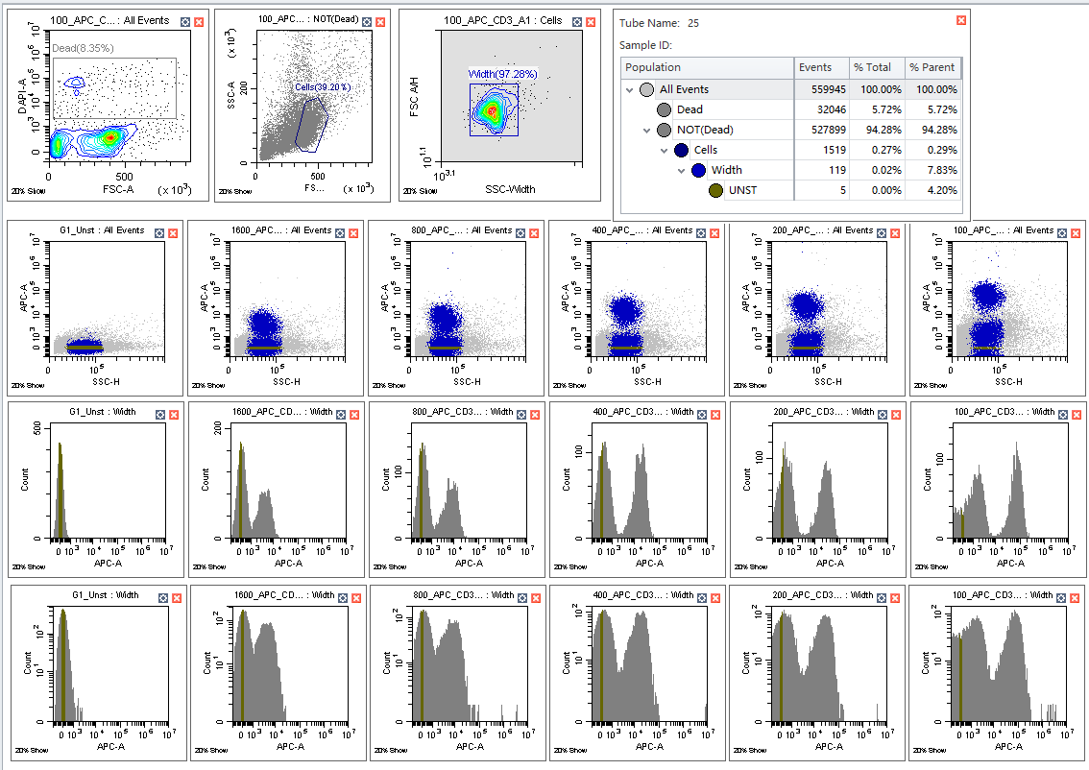

References
[1] Bonilla DL, Paul A, Gil-Pulido J, Park LM, Jaimes MC. The Power of Reagent Titration in Flow Cytometry. Cells. 2024 Oct 11;13(20):1677. PMID: 39451195.
[2] Cossarizza A, Chang HD, Radbruch A, et al. Guidelines for the use of flow cytometry and cell sorting in immunological studies (third edition). Eur J Immunol. 2021. PMID: 34910301.
[3] Collino CJG, Jaldin-Fincati JR, Chiabrando GA. Statistical criteria to establish optimal antibody dilution in flow cytometry analysis. Cytometry B Clin Cytom. 2007 May;72(3):223-226. PMID: 17420983.
[4] Whyte CE, Tumes DJ, Liston A, Burton OT. Do more with Less: Improving High Parameter Cytometry Through Overnight Staining. Curr Protoc. 2022 Nov;2(11):e589. PMID: 36373983.
[5] Vonficht D, Jopp-Saile L, Yousefian S, et al. Ultra-high-scale cytometry-based cellular interaction mapping. Nat Methods. 2025 Sep;22(9):1887-1899. PMID: 40775086.
[6] Skordos I, Demeyer A, Beyaert R. Analysis of T cells in mouse lymphoid tissue and blood with flow cytometry. STAR Protoc. 2021;2(1). PMID: 33665631.
[7] Valenzano G, Russell SN, Go S, O'Neill E, Jones KI. Using Spectral Flow Cytometry to Characterize Anti-Tumor Immunity in Orthotopic and Subcutaneous Mouse Models of Cancer. Curr Protoc. 2024 Oct;4(10):e70032. PMID: 39432378.
[8] Tung JW, Heydari K, Tirouvanziam R, Sahaf B, Parks DR, Herzenberg LA, Herzenberg LA. Modern flow cytometry: a practical approach. Clin Lab Med. 2007 Sep;27(3):453-468. PMID: 17658402
Acknowledgement:
Thanks for Hajar El Mssiah and Daphnee Levasseur Prof. Abdelaziz Amrani lab for representative plots of antibodies titration

