Immunostaining
ABCD-01 Cells were fixed in 1% paraformaldehyde for 30 minutes at 4°C, washed, then permeabilized with the saponin 0,1% for 30 minutes at 4°C. Multicolor immunostaining was performed using optimal concentrations of FITC; PE; PerCP etc -monoclonal antibodies directed to human CDx; CDxx; CDxxx etc. Corresponding isotype-matched mAbs from BD Company were used as controls to set background staining levels
After two washes in PBS containing 0.1% BSA, cells were resuspended in 100 μL of the same buffer containing 10 μg/mL of cell non-permeable propidium iodide to allow exclusion of dead cells, then analyzed by a Flow cytometry.

Cell Cycle Analysis
The cells were harvested by trypsinization, fixed with 96% ethanol, washed twice, resuspended in RNase containing buffer with 10 μg/mL of PI dye the fluorescence of which was collected at the sample flow rate 10 μL/min in red channel on a linear scale.
(to complete with the text from the section Fluorescence-Activated Cell Scanning)
The percentages of cells in different phases of cell cycle were calculated by ModFit software (Verity Software House).

Fluorescence-Activated Cell Scanning (Flow cytometry)
Cells were analyzed by a FACScan flow cytometer (Becton Dickinson, Mountain View, CA) equipped with a 15 mW argon ion laser tuned at 488 nm. The emitted fluorescence was split into three channels by dichroic mirrors and detected with logarithmic amplifiers through the following band or long pass filters: 530/30 nm - FITC, 585/42 - PE, and >650 - PerCP.
As sheath fluid reagent PBS was used and the sample flow rate was 60 μL/min (12 μL/min)

Cells were analyzed by a FACSCalibur flow cytometer (Becton Dickinson, Mountain View, CA) equipped with a 15 mW argon ion and red-diode lasers tuned at 488 and 635 nm respectively. The emitted fluorescence was split into four channels by dichroic mirrors and detected with logarithmic amplifiers through the following band or long pass filters: 530/30 nm - FITC, 585/42 - PE, and >670 - PerCP. A 661/16 nm for the APC
As sheath fluid PBS was used and the sample flow rate was 60 μL/min (35 μL/min or 12 μL/min)

Cells were analyzed by an automatic 96-well-plate loader equipped CytoFLEX flow cytometer (Beckman Coulter, Brea, CA, USA) cytometer with following diode lasers: 488 nm and 638 nm 50 mW each; 375 nm - 60 mW; 405 nm - 80 mW.
The emitted fluorescence was split into four (six; thirteen) channels by dichroic mirrors and detected through the following band pass filters:
if ....
CytoFLEX said “15” | CytoFLEX said “20- plate loader” | CytoFLEX said “30”
525/40 – FITC, 585/42 – PE, 690/50 – PerCP, 660/20 - APC, | 525/40 – FITC, 585/42 – PE, 690/50 – PerCP, 780/60 - PC7, 660/20 - APC, 780/60 - APC-A750. | 450/45 nm – DAPI, 675/30 - Hoechst Red, 450/45 - PB 450, 525/40 - KO 525, 610/20 - V610, 525/40 – FITC, 585/42 – PE, 610/20 – ECD, 690/50 – PerCP, 780/60 - PC7, 660/20 - APC, 712/25 - APC-A700, 780/60 - APC-A750.
As sheath fluid deionized water was used and the sample flow rate was 60 μL/min (or 30 μL/min or 10 μL/min)

Forward scatter area (FSC-A), side scattered area (SSC-A) and SSC-Width (SSC-W) signals were used to establish the live gates to exclude debris, and cell clumps. Dead cells (PI-positive) were excluded by the gating in the red channel. A minimum of 10,000 gated events by sample were acquired. The VersaComp Antibody Capture Beads were used to measure the single dye fluorescence spill over to neighbourhood channels. An electronic compensation matrix was used to correct this crosstalk between channels.

Afterwards gating strategies: lymphocytes were gated on CDx-FITC versus FSC-A scatterplot and then lympho+ and lympho- were gated using CDxx-PE vs. CDxxx-PerCP plot.

Fluorescence intensity distribution was analyzed with the CytExpert software (Beckman Coulter) CellQuest software (Becton Dickinson). A mean fluorescence intensity recorded for each cell population was subtracted by the respective autofluorescence observed in the control.
Results are expressed as
--- relative change in signal intensity compared to unstimulated control cells
--- the percentage of positive cells
--- fractions of the average value found for unstimulated control cells.
--- fold increase compared to the untreated condition
--- headmap of categorical expression of assigned markers

Fluorescent-activated cell sorting
Cells were detached with the Accutase solution ...., centrifuged and resuspended in cold sorting buffer (PBS; ImM EDTA; 25 mM HEPES pH 7.0; 1% FBS) at l x 10⁶ cells per ml. The cells were incubated for 20 min on ice with appropriate primary antibodies according to the manufacturers’ instructions. During the cell sorting experiment live cells were distinguished from dead cells with the LIVE/DEAD® Violet Viability/Vitality Kit (Invitrogen).
ABCD expressing cells were purified by sorting using the FACSAria cell sorter (BD Biosciences) equipped with four lasers (wavelength (nm) 405; 488; 561; 633) using a 100-pm nozzle at 20 psi. Cells labeled with fluorochrome-conjugated isotypic antibodies (BD PharMingen) were used to gate nonspecific fluorescence signals, and dead cells were excluded on the basis of propidium iodide (5 ug/mL, Sigma-Aldrich, St. Louis, MO) fluorescence intensity. The purity of cells preparations was always between 95% and 99%. Twenty percent to 30% were ABCD-positive , and 70–80% were ABCD-negative.
Sorting gates were defined based on unstained controls. A population of unsorted cells was also kept as a control.

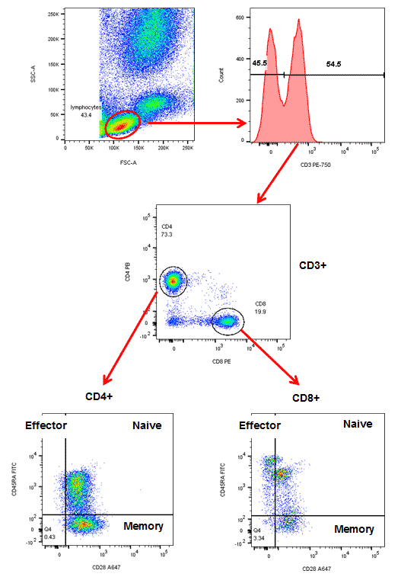 Image par Biorad.com
Figure xxx
Sequential gating to identify specific cells subsets.
Cells were stained with ***** in the presence of propidium iodide. Arrows show the gating strategy.

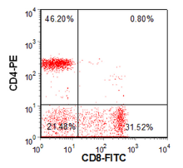 Image par Denovosoftware.com.

Figure xxx
CD4 / CD8 expression on the lymphocytes quantitated by quadrant analysis.

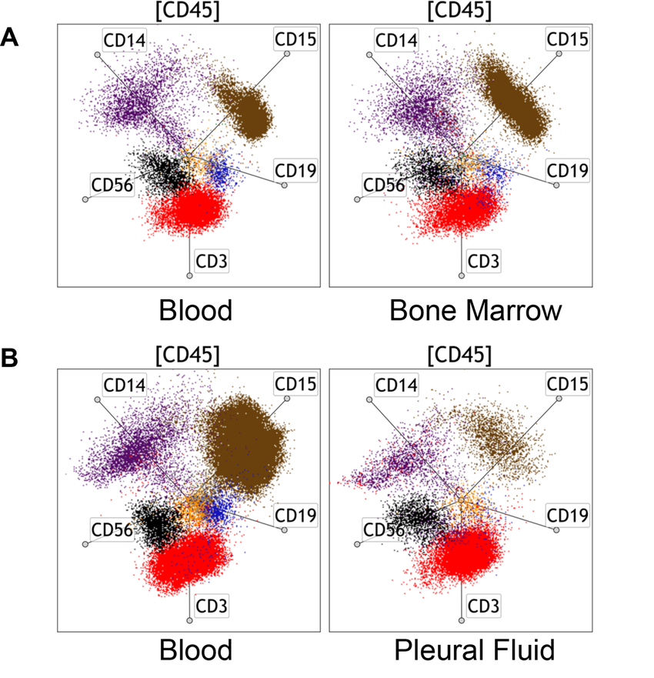 Image par Gustafson et al.
Fig xxx. Radar plot analyses on (A) peripheral blood and bone marrow samples from a case 1 and (B) peripheral blood and pleural fluid from a case 2.
The radar plot configuration includes CD3 (red), CD19 (blue), CD56 (black), CD14 (purple), and CD15 (granulocytes, brown) gated from total CD45+ cells ([CD45]) and the axes are identical across all samples.

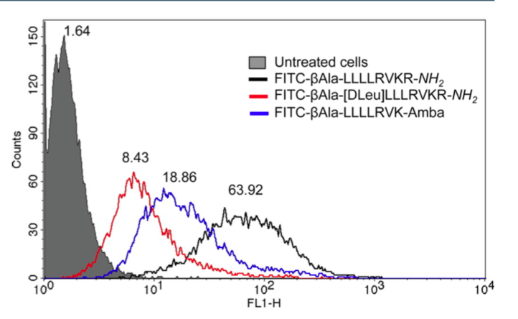Image par Kwiatkowska et al.

Figure xxx.
Cellular uptake of the fluorescent compounds by ABCD-01 cells.
The cells were treated with 10 μM FITC-labeled compounds, and the data were collected after 1 h incubation. Untreated cells were used as a control, and their autofluorescence intensity is presented as a gray curve. Numbers indicate the geometric mean fluorescence intensity.

